*Bruh.*

Project Portfolio

*4/7/2022*

0

# Introduction

Everyone wants to work out and look good, but not everyone does because it can be hard to find the motivation or know how to start. So, to help with this we are going to make an app that will allow people to work out and maximize results without having to be educated on health and the human body. This should make it easier for new people to get into working out and provide veterans with new ways of working out and the motivation to take it a step further.

# Expected Technologies:

For MileStone #3, we’ve decided to work with Flask, which is an app development tool that utilizes a mixture of Python, CSS, and HTML. Initially we will implement our Back-End locally, so both our Front and Back-End can be created using Ionic. In the future, if we are able to implement our stretch goals, we will have to use a database for the social media aspects of our app.

Core Features:

* Enter in your weight and height and get workout routines tailored to you
* Keeps track of your exercises from last week so you are finding new ways to work the same muscle groups

Viable Features:

* Enter a specific body type that you want to shoot for and get exercises that will help you work toward that body type
* Ability to make a weekly schedule which tailors workouts based on when the user has time
* Keep track of calories burned per exercise, added up to a total calories burned for a workout

Stretch Features

* Social media aspect (sharing workouts, etc)
* Nutritional Advice (Meal options to maximize workout gains proportional based on calories burned in the workout and the goal body type)

# The Bruh. Team [Bruh GitHub Link](https://github.com/anair14/3380-project-team)

# Members:

Ashwin Nair - Front-End Developer

Austin McBurney – Team leader for Milestone 1 / Front-End Developer

Christian Pentavin - Back-End Developer

Brandon Domangue - Back-End Developer

Jonathan Lagarrigue - Front-End Development

Jacob Carter - Back-End Development

David Robins – Front-End Developer

## User Stories

### User Story #1

*As an average person who does not know a lot about exercise and nutrition, I want to have an app that tells me what exercises I should work on and what I should eat, so I can stay healthy and in shape without having to take the time out of my day to research exercise and nutrition to find out what the most effective exercises are for someone with my body type.*

### User Story #2

*As someone who works out regularly, I want an app that will recommend new exercises every week so that I can keep track of what exercises I did the previous week so that the next time I work that muscle group I can do new exercises that will help maximize muscle gain for my time in the gym.*

# Project Management

## Continuity of Operations Plan (COOP)

Our group has established multiple sources of communication via GroupMe, Discord, and text. We plan to meet in-person, but having these online resources is useful in case anyone is unable to meet or is feeling ill. In the event of someone becoming unavailable to work on the project, we will have a plan on having a backup for taking over that person's responsibilities if needed. We also plan on meeting with our TA at the designated meeting times to ensure we are meeting our goals.

## Project Plan

### System Architecture Design and Development Milestone # 1

|  |  |  |  |  |  |  |  |  |
| --- | --- | --- | --- | --- | --- | --- | --- | --- |
| **#** | **Activity** | **Pre #** | **Estimated**  **Effort** | **Actual**  **Effort** | **Estimated**  **Start Date** | **Estimated**  **Finish Date** | **Actual**  **Start Date** | **Actual**  **Finish Date** |
| 1 | Design UI, Flowchart I/O stream |  | 5 hrs |  | 2/8/2022 | 2/11/2022 |  |  |
| 2 | Set Up Local Back-End |  | 10 hrs | 2hrs | 2/8/2022 | 2/14/2022 | 2/20/2022 | 2/22/2022 |
| 3 | Create Front-End Based UI Design | 1 | 10 hrs | 2hrs | 2/12/2022 | 2/16/2022 | 2/20/2022 | 2/22/2022 |
| 4 | Mesh Front-End and Back-End Development | 2,3 | 10 hrs | 1hrs | 2/14/2022 | 2/20/2022 | 2/20/2022 | 2/20/2022 |
| 5 | Debug App and Tweak UI | 4 | 5 hrs |  | 2/20/2022 | 2/22/2022 | n/a |  |

### System Architecture Design and Development Milestone # 2

Note: Original Design was made under the impression more needed to be completed by Milestone 2. This explains the lower effort expended as opposed to the estimated. It also explains the similarity in the Project Plans for Milestone 1 and 2.

|  |  |  |  |  |  |  |  |  |
| --- | --- | --- | --- | --- | --- | --- | --- | --- |
| **#** | **Activity** | **Pre #** | **Estimated**  **Effort** | **Actual**  **Effort** | **Estimated**  **Start Date** | **Estimated**  **Finish Date** | **Actual**  **Start Date** | **Actual**  **Finish Date** |
| 1 | Finalize UI |  | 5 hrs | 5 | 2/23/2022 | 2/28/2022 | 3/05/2022 | 4/5/2022 |
| 2 | Set Up Local Back-End |  | 10 hrs | 40 | 2/23/2022 | 2/30/2022 | 2/25/2022 | 3/24/2022 |
| 3 | Create Front-End Based UI Design | 1 | 10 hrs | 15 | 2/28/2022 | 3/5/2022 | 4/1/2022 | 4/6/2022 |
| 4 | Mesh Front-End and Back-End Development | 2,3 | 10 hrs | 20 | 2/30/2022 | 3/14/2022 | 4/6/2022 | 4/7/2022 |
| 5 | Debug App and Tweak UI | 4 | 5 hrs | 10 | 3/15/2022 | 3/24/2022 | 4/7/2022 | 4/7/2022 |

## Design

**System Architecture:**

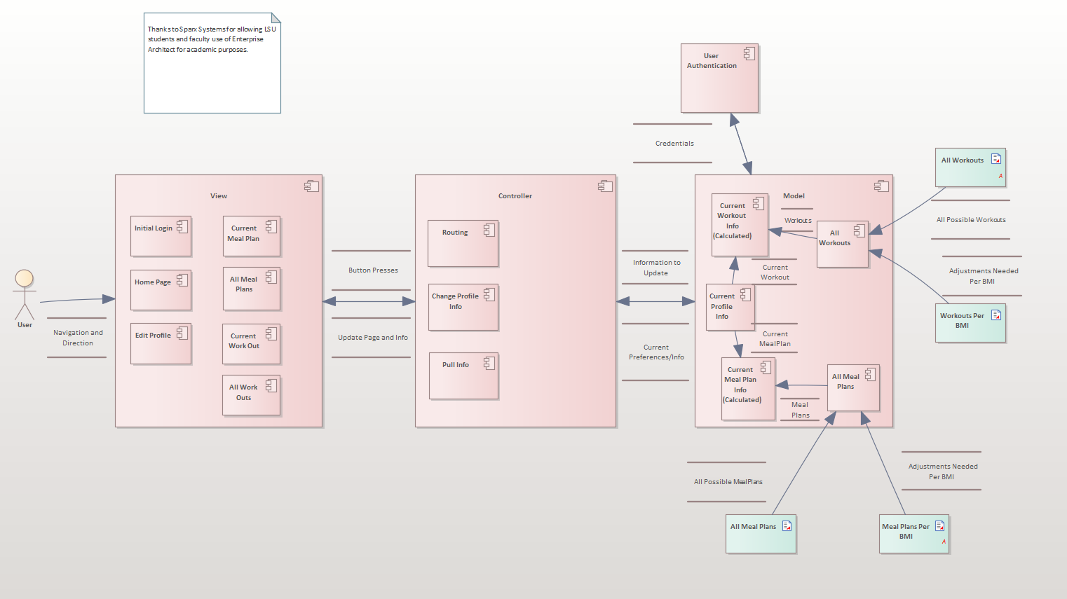 **Dataflow Diagram:**

**Milestone #3: Class Diagrams**

**Design Pattern Class Diagram:**